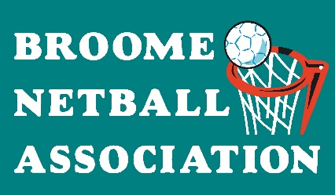

BROOME NETBALL ASSOCIATION

DUTY STATEMENT

REGISTRAR

OVERVIEW: To assist the administrator in membership registration for the Association and person responsible for all result entries

RESPONSIBILITES
- Attend all committee meetings where possible
When required complete the following duties in conjunction with the Administrator:
- Ensure the registration details for all members are recorded in MyNetball
- Maintain member records in MyNetball, including- games played, accreditation, awards, volunteer services, etc.
- Ensuring that relevant data is forwarded to Netball WA/ Association
- Ensure records are entered onto MyNetball for all competition match results at the end of each fixture round (Association only)
- Manage fixtures, entry of teams and relevant season information in MyNetball
- Print scorecards each week

SKILLS:
- Effective communication
- Strong organisation and record-keeping skills
- IT competency – familiar with basic operating systems, MyNetball, Microsoft Office, internet and email

TENURE:

- The position is for 2 yrs and/or between Annual General Meetings, to alternate the term with the Vice President to assist with continuity of the executive committee, and may be eligible for re-election for future terms.

